Government reshuffles Memorial Day lineup to keep divisive ministers from the bereaved
Ben Gvir left off list altogether after two years of protests, but spokesman says he will be at police ceremony; overhaul architect Levin moved from Nahariya to settlement bloc
By ToI Staff 28 April 2025
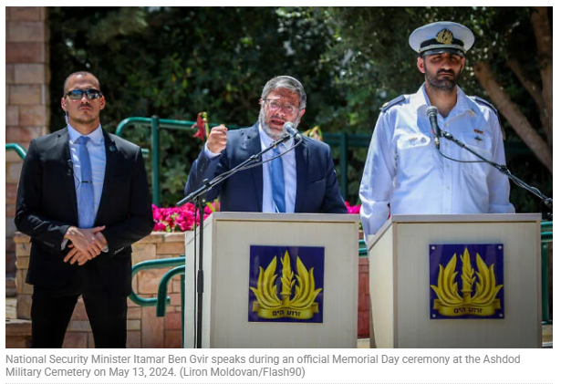
Several government ministers, including National Security Minister Itamar Ben Gvir and Justice Minister Yariv Levin, have been nixed from Memorial Day ceremonies in certain communities later this week following an outcry from bereaved families, according to a new list of planned appearances published Sundayby the Defense Ministry.
Ben Gvir, a right-wing firebrand whose appearance at ceremonies over the last two years provoked protests, did not appear on the list released by the Defense Ministry as appearing at any ceremony.
A spokesman for the minister, who is currently in the United States, said he would attend the central ceremony for fallen police officers at the Mount Herzl military cemetery in Jerusalem on Wednesday morning.
He did not answer questions regarding why Ben Gvir was not included in the Defense Ministry’s list of ministers’ appearances.
The Haaretz daily reported Sunday that Ben Gvir had initially planned to spend Memorial Day in the US, but decided to cut his trip short in the wake of criticism. The spokesman did not answer questions regarding the report.
Levin, whose plans to overhaul the judiciary sparked unprecedented protests in 2023, was initially set to attend a ceremony in Nahariya but was reassigned to the Etzion settlement bloc south of Jerusalem in the West Bank.
According to Hebrew media reports, bereaved families in the northern city had objected to Levin’s presence as a representative of the government.
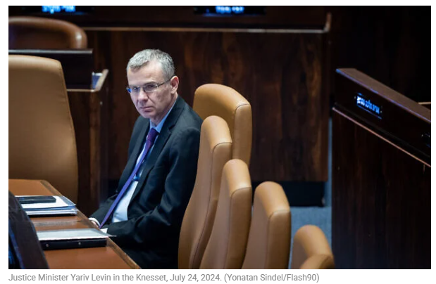
Yitzhak Wasserlauf, minister for the Development of the Periphery, Negev and Galilee, will be sent in his stead, according to the list.
According to a Haredi news report, Deputy Transportation Minister Uri Maklev refused an offer to attend the Gush Etzion ceremony, claiming that the predominantly Religious Zionist settlement bloc is hostile to the ultra-Orthodox, and said he preferred “to go anywhere else.” His office did not deny the report.
In the Druze town of Usfiya, Education Minister Yoav Kisch will attend a ceremony instead of Etti Atia, a Likud MK who heads the Knesset Foreign Workers Committee.
The switch came after Rafik Halabi, mayor of the nearby Druze town Daliyat al-Karmel, took to X to express outrage over the fact that no government minister would be attending the national ceremony for fallen Druze soldiers.
“There are no ministers, no emotion, no respect, no regard. Tired of the contemptuous disdain. Thirteen Druze fallen, IDF soldiers, died in Operation Iron Swords. Hundreds more in Israel’s wars. Shame on you!!” Halabi wrote.
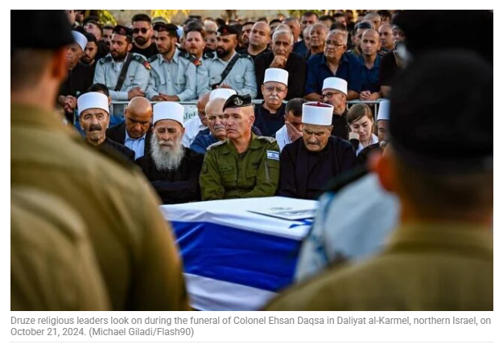
Defense Minister Israel Katz will also not attend a cemetery ceremony this year, due to a Jewish custom barring descendants of priestly Kohanim from being in the presence of the dead. Katz will instead deliver remarks at the Hall of Remembrance on an area of Mount Herzl, according to Hebrew media reports.
Memorial Day is considered among the most solemn days on Israel’s national calendar, with ceremonies and other events honoring the memory of soldiers, security personnel and terror victims killed since 1860. Attendance by government representatives at memorials and military cemeteries is considered de rigueur, sometimes sparking tense confrontations between mourners and lawmakers.
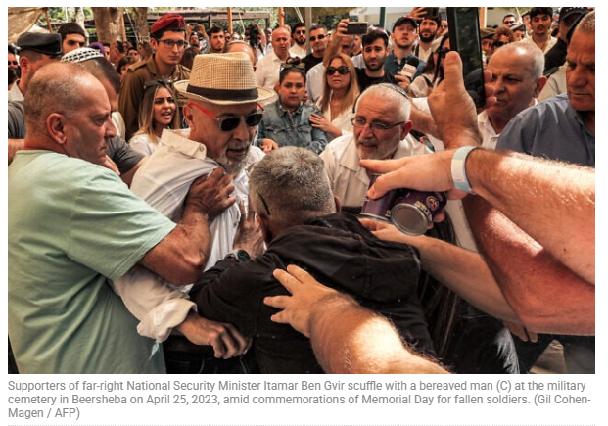
In 2023, Ben Gvir insisted on speaking at a Beersheba ceremony despite opposition from bereaved families who had asked politicians not to attend amid the controversial and polarizing judicial overhaul attempt.
Violent confrontations broke out between Ben Gvir’s supporters and attendees, disrupting the ceremony and causing many families to leave.
Last year, with the weight of the October 7 attack hanging heavily over the day’s remembrances, similar scenes played out when Ben Gvir attended a ceremony in Ashdod, with protesters calling the far-right politician, who did not serve in the military and who has opposed a deal to release hostages, a “criminal” and “draft dodger.”
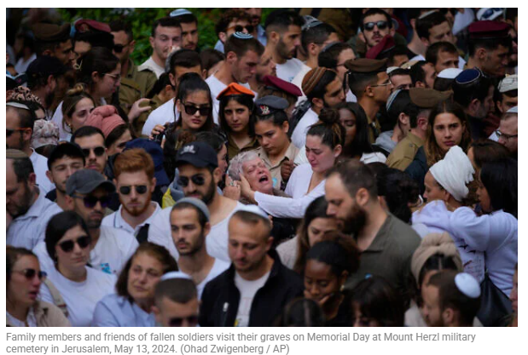
Ahead of this year’s ceremonies, Eli Ben-Shem, chairman of the Yad Labanim organization for bereaved families, sent a letter to Prime Minister Benjamin Netanyahu and Katz, urging them to coordinate with families and act with “discretion and responsibility” in assigning officials to ceremonies.
“This year, more than ever, there is heightened sensitivity and tension regarding the ceremonies,” Ben-Shem wrote. “Sadly, in recent years, we have experienced disruptions that harmed the dignity of the fallen and their families.”
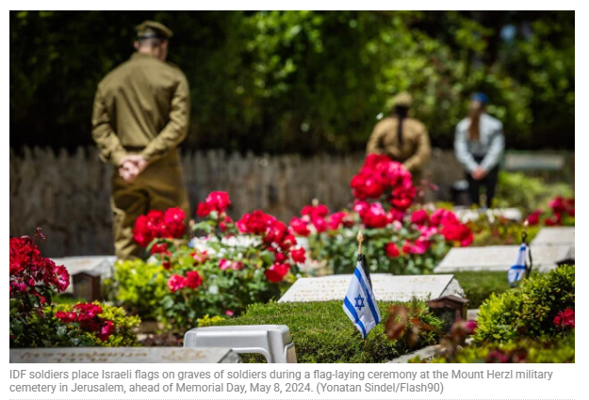
Ben-Shem urged the government to assign ministers only to locations where their presence would not provoke controversy, in order to preserve the “unifying and sacred nature of the day.”
Last year, the government’s decision to assign ministers to various Memorial Day commemorations across the country without consulting bereaved families sparked a heated backlash, with critics accusing decision-makers of showing insensitivity as the nation collectively mourned its fallen for the first time since the October 7, 2023, attack, during which some 1,200 people were killed and 251 kidnapped to Gaza, where many more of them died.
Ben-Shem noted that many bereaved families want only politicians who have served in the army or who have performed national service to attend ceremonies. Several ministers in the government do not meet that standard.
The families’ request comes as tensions have risen over the government’s efforts to advance legislation aimed at exempting large swaths of the ultra-Orthodox community from military service, even as Israel continues to fight in Gaza and casualty figures rise.

